Organisation Mondiale pour l'Education Prescolaire
World Organization for Early Childhood Education
Organización Mundial para la Educación Preescolar

Ο.Μ.Ε.Ρ.
Vice President for Europe
Department of Educational Science
and Early Childhood Education
University of Patras 265 04 RION – Greece December 2018

To European National Committees
Dear Presidents and Dear Members of National Committees in our region,
First of all I would like to wish you

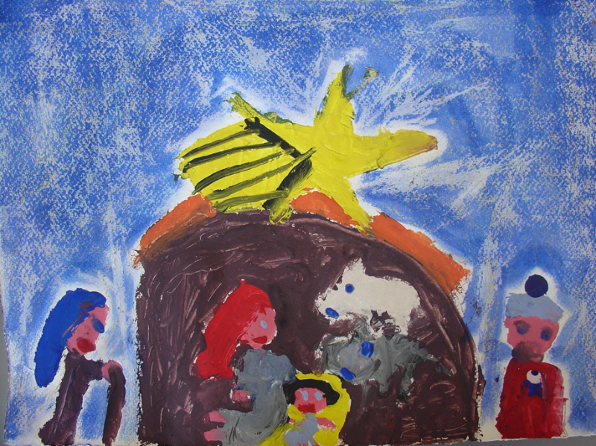
Nativity: painted by a 7 years old child from Greece The flight to Egypt

Merry Christmas and a Happy, Peaceful and Fruitful New Year!!!
Joyeux Noël et Bonne année!!!
¡Feliz Navidad y Próspero Año Nuevo!

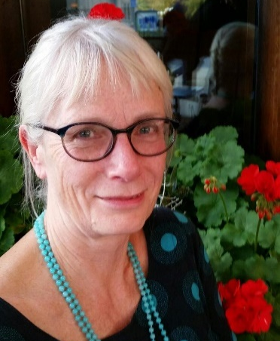
- Congratulations!
A new Vice President for Europe was elected in our World Conference in Prague and she is going to be “on board” from January 1, 2019.
I am sure that Ingrid Ingrid Engdahl, nominated by Swedish Committee and elected unanimously by the World Assembly, will have a very distinctive and successful leadership. She is strongly motivated and persistent and I sure that she will pursue her goals of success.
Congratulations! Warm wishes!

- World Assembly and European Conference
Two important events are going to be held this year. Our Regional European Conference in Lisbon, Portugal in May and the World Assembly and Conference in Panama. Unfortunately, we are still waiting for concrete information and websites.
- Sincere Thanks
I would like to thank you all from the deep end of my heart for your support throughout the last six years. It was an amazingly active period in my life. A lot of work, trips, knowledge, experiences, meetings and friendships. I am grateful to all of you. I can assure you that I tried to do my best, but this is not me who can judge how successfully I managed to response to my duties. I do know that there are two issues that I did not manage to persuade you to follow my advice: a) to collaborate and build partnerships with Committees from Africa Region, and b) to initiate projects for supporting refugee children or children on the move. I do apologize for that.

I would like to thank the World Presidents, Ingrid, Maggie and Eunhye and the Executive Committee members as well as my predecessor, Milada Rabusicova, from which I gained a lot of knowledge, experience on leadership and strong friendships.
I would like to assure you that I will stand beside our new Regional Vice-President, Ingrid, ready to respond to whatever she asks me for. I will continue to work of OMEP and its vision for a better early childhood education, care and development for all children of the world and especially those who live in vulnerable situation or need special assistance. Finally, I will keep my memories in the best place of my memory and I will pay any effort to keep our friendships vivid. Thank you all for everything!
With my warmest regards and looking forward to hearing your news, the events organizing by your Committee, initiatives of your members, collaborations and any other activity of yours.
Nektarios Stellakis, Vice President of OMEP for Europe

