|  |  |
| --- | --- |
| [http://t1.gstatic.com/images?q=tbn:ANd9GcTG10mdaXZcPspj5sXSG2g6ZKBBJORBqSgIB33b6lkR-NWsbEXy](http://www.google.com.cy/imgres?imgurl=http://4.bp.blogspot.com/_AypZ17iEE7I/TOQ0PDYxarI/AAAAAAAAABY/I75Ts5xzRGc/s320/logo_omep.gif&imgrefurl=http://omepkritis.blogspot.com/&h=235&w=283&sz=13&tbnid=iRdlwpU-OXlBkM:&tbnh=95&tbnw=114&prev=/search?q=omep+logo&tbm=isch&tbo=u&zoom=1&q=omep+logo&usg=__QQX5H7OveGO3TO7Q_OZ0gdwSIec=&docid=1ItSx_LktsbDbM&sa=X&ei=qr6dUbu_Cumy7AbOzYHICg&ved=0CDEQ9QEwAg&dur=2328) | **O**rganisation **M**ondiale pour l'**E**ducation **P**rescolaire  World Organization for Early Childhood Education  Organización Mundial para la Educación Preescolar  Ο.Μ.Ε.Ρ. |
| **Vice President for Europe**  Department of Educational Science  and Early Childhood Education  University of Patras 265 04 RION – Greece December 2017 | |

To European National Committees

Dear Presidents and Dear Members of National Committees in our region,

First of all I would like to wish you

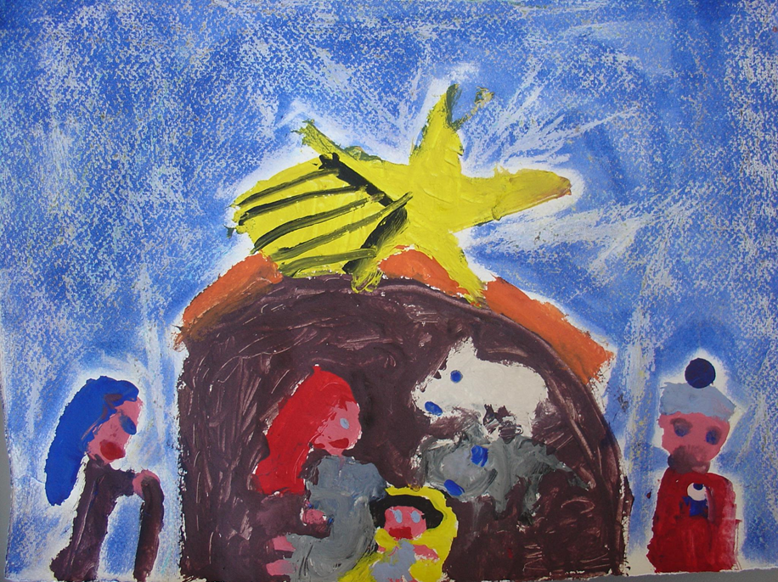

**Merry Christmas and a Happy, Peaceful and Fruitful New Year!!!  
Joyeux Noël et Bonne année!!!  
¡Feliz Navidad y Próspero Año Nuevo!**

1. The main event in our Region the New Year 2018 is the **70th World Assembly and Conference**, which is going to be held in Prague, Czech Republic, 25-29 of June 2018.

The Conference website with all the relevant information is: <https://konference2018.omep.cz>

Its topic is **“Conditions of Early Childhood Education Today: A foundation for a sustainable future”**. You are kindly requested to spread the information among your members and academia in your country. Please, notice that deadline for Proposal Submission is 15th of January 2018. This is why you should spread the information as soon as possible.

1. **70th Anniversary Year**

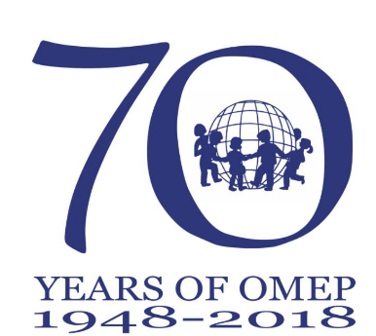2018 is our 70th Anniversary Year. You are kindly requested to participate in the official celebration project, but also I invite you to organize special events and projects for your country. EXCOM has decided to launch an OMEP Journal of Theory into Practice and the Inaugural Issue, which is dedicated to 70th anniversary, has the title: Constructing Early Childhood Cultures of Peace, Rights, Play, and Participation. You have received relevant information from World Secretary, but please, notice that submissions should be send to me until the end of this year.

1. **Election of the next VP for Europe.**

During our Regional Meeting in Opatije we all agreed with the Swedish suggestion that the forthcoming elections for the next Regional VP for Europe should be an open and democratic process. Every country should have a discussion and all countries should both nominate and vote. It was agreed that during January 2018 each committee would send in a nomination. For that reason, I have opened an online survey to include all countries and send this out to enable every Committee to suggest. I am sending you the link and I kindly ask you to send your proposals by 20th of January 2018:

<https://docs.google.com/a/cb.victoria.edu.hk/document/d/1WFDgULwhPAbCYt2sBwMeFAmsoEfxvgXJGVI-v2nVWqs/edit?usp=sharin>

Those who have not a google account either can register or send me their proposal.

With my warmest regards and looking forward to hearing your news, the events organizing by your Committee, initiatives of your members, collaborations and any other activity of yours.

***Nektarios Stellakis,*** Vice President of OMEP for Europe